23 October 2014

Dr Virginia Barbour
Chair of Council
Committee on Publication Ethics

Dear Dr Barbour
In light of your advice as Chair of the Committee on Publication Ethics (COPE), we are writing to draw your attention to our concerns about editorial actions at the British Medical Journal related to its handling of problems with the BMJ’s 22 October 2013 papers by Abramson¹ et al and by Malhotra².
The BMJ’s Editor (Dr Godlee) is running a “Too Much Medicine” campaign³ and has indicated⁴ that those papers are likely to have been published in the BMJ due to that campaign. However, debates as to what constitutes “over-medication” (and, indeed, what constitutes under-medication) should be conducted on the basis of objective and impartial presentation of the scientific evidence.
Both papers under-stated the beneficial effects of statins and greatly over-stated their side-effects (with one particularly glaring error already having to be withdrawn). It has been shown in large-scale randomised-controlled trials⁵ that effective use of statin therapy reduces the rates of vascular deaths, heart attacks, ischaemic strokes and revascularisation procedures (typically preventing about 60-120 such events per 1000 patients with vascular disease treated for 5 years), with rates of side-effects⁶ that are comparatively low (about 5-10 adverse events per 1000 during 5 years of treatment).
We are concerned that misrepresentations in the BMJ of the evidence on the safety and efficacy of statins have led to people stopping their statin therapy or not starting it. For example, in the recent British Cardiovascular Society survey⁷ of its members, 60% of the respondents reported that they had patients with clear indications for statin therapy who had stopped it due to the confusion caused by recent publications and related media coverage. Among patients who are at elevated risk of heart attacks and strokes in particular, this could be resulting in many heart attacks, strokes and vascular deaths that could have been avoided by the use of statin therapy.
Consequently, given the public health implications, we are seeking advice from COPE as to whether the BMJ’s handling of this matter, as described below (with embedded links to supporting materials), has been consistent with COPE’s Code of Conduct and Best Practice Guidelines for Journal Editors.

Publishing incorrect side-effect claims despite being advised they were misleading
In a section of their paper entitled “Myopathy”, Abramson et al⁸ misleadingly compared the 5-year excess with statin therapy of 0.5 per 1000 for myopathy⁹ (i.e. a severe muscle problem with a specific definition) in the randomised placebo-controlled trials with the excess of 53 per 1000 for muscle pain in the NHANES observational study¹⁰ (which did not assess myopathy but was instead based on reports of musculoskeletal pains of any severity and, crucially, had no “blinded” comparator group), and stated that the “increase in muscle pain is 100 times greater than that reported in clinical trials”.
In commenting on that claim prior to publication, one peer reviewer (Smeeth) stated¹¹: “The results presented for myopathy are misleading [our emphasis]. NHANES focused on ascertaining symptoms from people exposed to statins. Muscle pain is incredibly common in the general population and is thus incredibly common among people both treated and not treated with statin. In the randomised Heart Protection Study, almost one third of people in both arms (i.e. including the placebo arm) complained of muscle pain and the effect estimate was 0.99 (95% CI 0.95 to 1.03).”
Despite this clear warning, a BMJ editor is recorded as saying¹² in an editorial meeting: “Smeeth’s review hints they may have overstated harms. Still it probably doesn’t matter too much [emphasis added]. If they have got it wrong people can say so in the RRs [Rapid Responses]”. However, when Cochrane Collaboration statin trial reviewers¹³, and others, pointed out this error in Rapid Response letters, the BMJ allowed Abramson et al to repeat their misleading claim¹⁴ instead of correcting it.
It is of concern that an editor at the BMJ would suggest that it does not matter to publish misleading information, and raises questions about standards for which the Editor is responsible (in accordance with articles 1.1 and 8.1 in COPE’s code of conduct). Moreover, the BMJ has still not corrected this error (which is entirely distinct from the partially corrected error in both the Abramson et al and Malhotra papers that related to a paper by Zhang et al: see below).
We would invite your views as to whether this contravenes COPE’s Code of Conduct, including articles 1.1, 1.6, 1.8, 8.1 and 12 (“Ensuring the integrity of the academic record: 12.1 Errors, inaccurate or misleading statements must be corrected promptly and with due prominence”.)
Publishing a misleading “correction” of other incorrect side-effect claims
The papers by Abramson et al and by Malhotra both misrepresented the report of an observational study by Zhang et al¹⁵ by claiming that it showed that side-effects were caused by statins in 18-20% of patients who took them. However, the evidence in the Zhang paper does not support these alleged rates of side-effects, and Zhang and his co-authors did not conclude that it did so.
After a considerable delay, the Editor accepted that this had been an error, but she then drafted and published a “correction” on 15 May 2014 that was itself not correct.
In her accompanying editorial¹⁶, the Editor states “The text of the correction, which includes a further interpretation of Zhang and colleagues data, has been peer reviewed”. However, a peer reviewer (Smeeth) made it clear in his advice (provided on 9 May)¹⁷ that he did not agree with the proposed correction: “undertaken a new misleading calculation to come up with a figure of 9%… interpreting this as being the people who had side effects caused by statins is plainly wrong [emphasis added].”
The Editor did not accept the peer reviewer’s advice, saying¹⁸: “… I sent the text of the correction to Zhang et al, and they have come back saying they are happy with the interpretation placed on their data in the correction, so I propose to leave the 9% figure as it stands”. The published correction states ¹⁹: "The correct interpretation of the data, as confirmed to The BMJ by Zhang et al [emphasis added], is as follows… 9% of the study population having possibly discontinued statin therapy as a consequence of statin related events rather than the 18% cited”.
However, following publication of the correction and the Editor’s accompanying editorial, Zhang et al submitted a Rapid Response letter²⁰ to the BMJ that was published on 28 May. That letter forcefully reiterates that “The goal of our study was never to establish the rate of adverse reactions caused by statins, which would be impossible using the tools we employed”. In subsequent correspondence²¹, the senior author of the Zhang et al paper has written “when we read the BMJ correction as it was published [our emphasis], we wrote a letter in an attempt to further clarify any misconceptions”.
We would invite your views as to whether the manner in which this process of peer review was conducted, and the manner in which the subsequent checking with the authors of the paper was conducted, contravenes COPE’s Code of Conduct (including articles 1.6, 7.1, 8.1 and 17.1).
Publication of inaccurate editorial and media statements accompanying the published “correction”
In the same editorial (15 May 2014), the BMJ’s Editor stated²² that “Abramson and colleagues’ article was submitted and peer reviewed…The initial submission reported that Zhang and colleagues found that ‘18% of statin treated patients had discontinued therapy because of statin related events’. This was a misreading of Zhang and colleagues’ data that was not picked up by the peer reviewers...”. (This claim was repeated in the BMJ’s press release²³ and on the BBC Radio 4 Today programme.)²⁴
However, this account is inaccurate (and, indeed, the BMJ’s editorial team had advised the Editor prior to publication that the peer reviewers had not seen the text containing this error: see below).
The Editor refers explicitly to the initial submission in her editorial when she asserts that the peer reviewers missed the misrepresentation of the Zhang paper. However, it is clear from the materials posted on the BMJ’s website²⁵ that the paper by Zhang et al was not referred to in the original draft ²⁶ of the paper by Abramson et al that had been peer reviewed (and so, of course, the peer reviewers could not have picked up the misrepresentation of the paper, which was added at a later stage).
This error is a matter of considerable concern, especially since the Editor had been asked specifically in letters that were sent to her on 31 March, 14 April and 25 April²⁷ 2014 to check the peer reviewers’ comments with regard to the misrepresentation of Zhang et al’s paper in particular.
Furthermore, the Editor was informed by the BMJ’s analysis editor²⁸ non 8 May (i.e. a week before the editorial was published) that the reviewers had not seen the revised draft of the paper by Abramson et al that referenced the Zhang paper: “the incorrect fact…seems to have been inserted at the final stage of editing… This has two implications, firstly that the peer reviewers did not scrutinise the 18% fact in particular and they may well have picked this out as erroneous… not re-reviewed externally”.
This failure to provide an accurate account was then compounded by the delay in correcting the statement after one of the peer reviewers contacted the Editor about it, immediately following its publication, on 16 May 2014²⁹. A correction was only put on the BMJ website on 27 May³⁰, when most of the people who were going to read the editorial (including the media) had already done so and, consequently, would not have been made aware that it was inaccurate. [Note: The editorial was accessed over 24,000 times during May³¹, whereas the correction only 1600 times³² by the end of June.]
We would invite your views as to whether this conduct contravenes COPE’s Code of Conduct, including article 8.1 (“should take all reasonable steps to ensure the quality of the material they publish”) and article 12.1 (“errors, inaccurate or misleading statements must be corrected promptly and with due prominence”).
Inappropriate use of Abramson to review the accompanying paper by Malhotra
The papers by Abramson et al and by Malhotra published on 22 October 2013 both misrepresented the paper by Zhang et al in the same way by mistakenly saying that it showed that side-effects were caused by statins in 18-20% of patients who took them. It eventually emerged that Malhotra’s paper had been reviewed by Abramson himself, which would seem to be quite irregular.
The reviewers’ comments for both papers had been sought repeatedly in letters sent during March and April 2014³³, but whereas the peer reviewers’ comments for the paper by Abramson et al were made available on the BMJ’s website when corrections for both papers were published on 15 May 2014, the peer reviewers’ comments for the Malhotra paper were not.
The Editor was subsequently reminded on 21 May ³⁴ that peer reviewers’ comments for Malhotra’s paper had not been made available, and her panel’s Chair was reminded again on 30 May³⁵, but they were still not released. It was only when a further request was made on 3 July³⁶ that the reviewers’ comments for the Malhotra paper were made available on 7 July, after a 3 month delay. The Editor stated that they had not previously been made publicly available due to a “technical problem”³⁷.
This explanation is somewhat surprising given the number of times that the Editor had been asked for these reviewers’ comments and reminded that they had not been made available. However, it is understandable that there might well have been reluctance at the BMJ to make it publicly known that the only reviewer of this parallel paper to the one by Abramson et al was Abramson himself.
We would invite your views as to whether this conduct contravenes COPE’s Code of Conduct, including article 7.1 which requires that Editors “strive to ensure that peer review at their journal is fair, unbiased and timely”, as well as the Best Practice recommendation for Editors of “ensuring that appropriate reviewers are selected for submissions (i.e. individuals who are able to judge the work and are free from disqualifying competing interests)”.
Questionable independence of the BMJ’s review of published errors
In her editorial of 15 May 2014, the BMJ’s Editor stated³⁸ that she would set up an “independent panel ... whose members will include people with no ‘dog in this fight’…” to decide whether to retract the papers by Abramson et al and by Malhotra. Instead, however, not only did the Editor determine the terms of reference, but she also personally chose³⁹ all of the panel members.
In our view, these terms of reference⁴⁰ were unduly limited in their scope. Although the panel’s report is written carefully, its conclusions as to what constitutes harmful misinformation are not easy to accept. The panel stresses⁴¹ that the two papers are "Analysis and Observation pieces" intended to "provide a commentary". However, since articles of this type are typically aimed at a wide range of practitioners and may well be taken up by the media, it is reasonable to expect that particular care would be taken to avoid publication of misleading or incorrect analysis. We would question whether the panel has been rigorous enough in dealing with the issues, including its decision⁴² not to consider the adverse impact of misleading claims on patient safety.
By any normal standards of judgment, none of the review panel members⁴³ could be considered to be independent of the BMJ. For example, the chair and the 6 other panel members are either current or past members of BMJ committees (e.g. Editorial Advisory Board, Hanging Committee, Primary Care Advisory Panel, Ethics Committee), and the panel secretary was previously the BMJ’s Deputy Editor and had dealt with the paper by Abramson et al when it was originally submitted.
Nor were the members independent of the issue. At least 6 have published papers about statin side-effects: these included an undeclared paper⁴⁴ by the chair claiming statins cause cancer in the elderly and a paper⁴⁵ by another member claiming that statins cause an excess risk of cataract about as large as the reductions in vascular events (both published in the BMJ and both refuted by the randomised trial evidence⁴⁶), and another undeclared paper⁴⁷ by a panel member that made similar claims about the efficacy of statins to those made in the Abramson paper (as did the paper⁴⁸ by the panel’s chair).
Moreover, at least one panel member (Furberg) had been paid for litigation work related to statin therapy⁴⁹ ⁵⁰ which has not yet been declared, and he had also published an undeclared paper⁵¹ in the BMJ in September 2013 about clinical practice guidelines for statins and other treatments which involved Abramson⁵² as a collaborator (see below for an additional conflict of interest related to that paper).
This information was not fully disclosed by the BMJ in its widely publicised statements, including in the description of the panel members on its website. When the panel’s report was published some more, but not all, of these potential conflicts of interest were declared. We would invite your views as to whether this conduct contravenes COPE’s Code of Conduct (including articles 17. 1 and 17.2).
BMJ links to public statements in support of its own position
By virtue of its position, the BMJ is able to exert considerable influence over the manner and context in which events are presented. It has a clear responsibility to its readers and members of the public at large to present matters of significant public health concern in a balanced and objective manner.
The “Timeline of events” on the BMJ’s website highlights a letter⁵³ signed by about 500 people, which called on the BMJ and its panel not to retract these articles, as supportive of the BMJ’s approach. What is not made clear, however, is that a journalist (Jeanne Lenzer) who is paid to work for the BMJ⁵⁴ was involved in coordinating that letter and that she had attempted to have it published⁵⁵ in another medical journal without making her BMJ links known.
Nor has it been made clear that that journalist was a co-author of the September 2013 BMJ paper⁵⁶ (see above) about the development of guidelines for statin therapy (and other treatments), in which Abramson himself is listed as a collaborator⁵⁷, with a member (Furberg) of the BMJ’s review panel that was considering whether to retract the paper by Abramson et al.
We would invite your views as to whether this conduct contravenes COPE’s Code of Conduct (including articles 17.1 and 17.2).
Inaccurate statements about materials posted with the review panel report
Both the review panel’s report and the Editor’s accompanying editorial state unequivocally that the BMJ has put all of the materials submitted to the panel on its website alongside the panel’s report (as had been stated⁵⁸ would be done at the beginning of the process). In particular, the Editor wrote ⁵⁹: “As part of our commitment to transparency, all documents submitted to and produced by the panel are published online (thebmj.com/statins)” [emphasis added].
Unfortunately, that statement is inaccurate.
Malhotra and others sent a letter on 19 June 2014 to NICE and the Secretary of State for Health (and the media) in which they made a number of claims about the safety of statins. It is clear that the BMJ considers that letter to be relevant since it refers to it in its “Timeline of events”⁶⁰ on the review panel section of its website. However, a detailed submission to the review panel⁶¹ describing serious errors in that letter, and their relevance to the panel’s review, has not been put on the BMJ’s website.
This omission has been drawn to the attention of the BMJ’s Editor and the chair of her panel. They have, however, refused⁶² both to have the submission put with the report and to provide any reasons for not doing so, despite it having been pointed out⁶³ that this action is entirely inconsistent with their explicit statements that all of the submitted materials have been put on the website with the report.
Moreover, by drawing attention to the letter to NICE by Malhotra and his colleagues, the BMJ is propagating the misinformation that it contains despite the serious errors in it having been drawn to the attention of the Editor. [Note: The Lancet has now published a peer-reviewed letter⁶⁴, along with supporting materials⁶⁵, describing the extent of these errors and their significance for public health.]
In addition, the BMJ redacted other material that had been submitted to it, in what it put alongside the panel report, for what it asserts are legal reasons⁶⁶. In one particular case, the BMJ has redacted the following statement from the letter submitted⁶⁷ by Professor Eugene Braunwald, Distinguished Hersey Professor of Medicine at Harvard Medical School:
“I am deeply disturbed by these two papers, particularly the paper by Abramson et al. I believe very strongly in the “free speech rights” in the First Amendment of the Constitution of the United States and I do not support censorship of any kind, especially in science which often advances as a result of controversy. However, it is well understood that this amendment does not give anyone the right to falsely shout “Fire” in a crowded room.”
The argument that redaction of this statement was made on legal grounds is untenable.
We would invite your views as to whether this conduct contravenes COPE’s Code of Conduct (including articles 14.1, 15.1 and 17.1).
Request for COPE to investigate failures to comply with its Editorial Code of Conduct
This letter addresses issues of public health significance. We have set out our concerns about the manner in which the BMJ has dealt with this matter, both during the review process and following publication. We would now invite COPE’s views on whether its Code of Conduct for Journal Editors has been contravened and, if so, what steps will be taken to rectify the situation.
Yours sincerely,
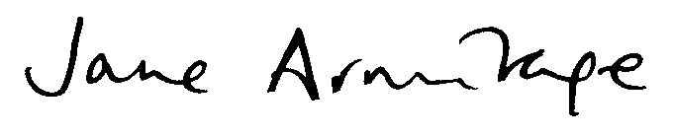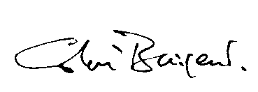
Professor Jane Armitage, FRCP FFPH Professor Colin Baigent, FRCP FFPH
Professor of Clinical Trials and Epidemiology Professor of Epidemiology
University of Oxford, Oxford, UK University of Oxford, Oxford, UK
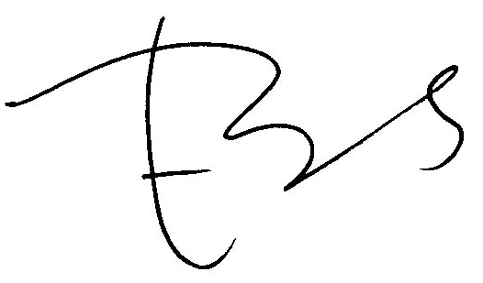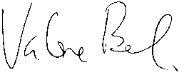
Professor Emily Banks, FAFPHM PhD Professor Dame Valerie Beral, FRS FMedSci
Professor of Epidemiology and Public Health Professor of Epidemiology
Australian National University, Canberra, Australia University of Oxford, Oxford, UK
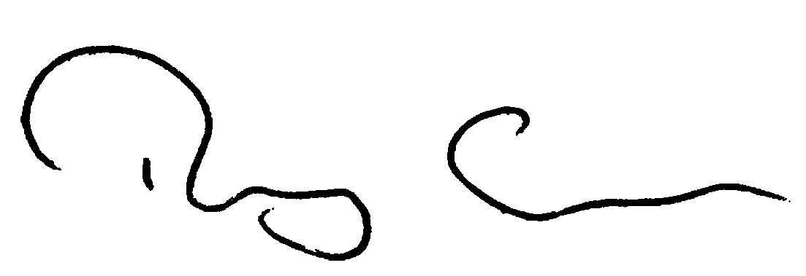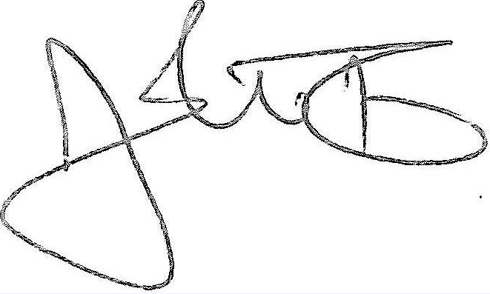
Professor Sir Rory Collins, FMedSci FRCP(E) Professor John Danesh, FRCP DPhil
BHF Professor of Medicine and Epidemiology BHF Professor of Epidemiology and Medicine
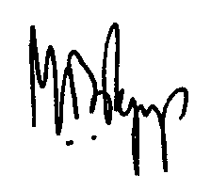
University of Oxford, Oxford, UK University of Cambridge, Cambridge, UK

Professor Stephen MacMahon, FAA FMedSci Professor Sir Mark Pepys, FRS FMedSci
Professor of Medicine Director, Wolfson Drug Discovery Unit
University of Oxford, Oxford, UK University College London, London, UK
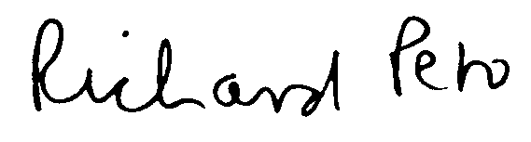
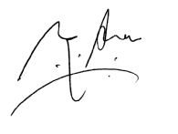
Professor Sir Richard Peto, FRS FMedSci Professor Neil Poulter, FMedSci FRCP
Professor of Medical Statistics and Epidemiology Professor of Preventive Cardiovascular Medicine
University of Oxford, Oxford, UK Imperial College, London, UK

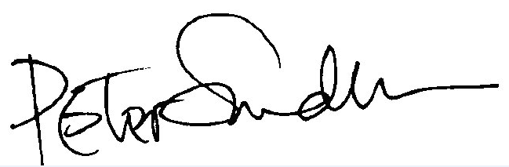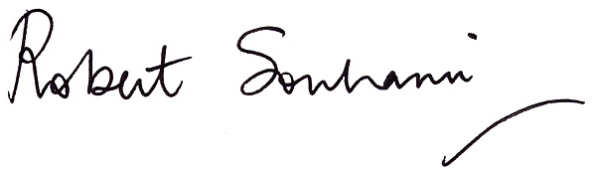
Professor Peter Sandercock, FMedSci DM Professor Robert Souhami, CBE FMedSci
Professor of Medical Neurology Emeritus Professor of Medicine
University of Edinburgh, Edinburgh, UK University College London, London, UK

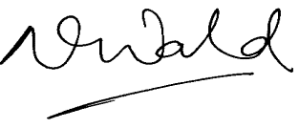
Professor Sir Nicholas Wald, FRS FMedSci
Professor of Environmental and Preventive Medicine
Queen Mary University of London, London, UK

cc Baroness Ilora Finlay, President of the British Medical Association
Disclosure of interest: Some (but not all) of us have previously drawn attention to errors in the BMJ papers by Abramson et al and by Malhotra and the letter sent to NICE by Malhotra and colleagues, have been involved in the Cholesterol Treatment Trialists collaborative meta-analyses that were criticised in those articles and the letter, have received research grants from pharmaceutical companies that make statins, hold patents related to statins (e.g. genetic tests; poly-pill), and/or have received honoraria from pharmaceutical companies for giving advice or presentations.

Supporting materials attached

- Abramson et al. Should people at low risk of cardiovascular disease take a statin? BMJ 22 October 2013
- Malhotra. Saturated fat is not the major issue. BMJ 22 October 2013
- Too much medicine campaign. BMJ online October 2014
- Godlee. Re: recent articles on statins safety and efficacy. Email correspondence October 2013
- Cholesterol Treatment Trialists’ (CTT) Collaborators. The effects of lowering LDL cholesterol with statin therapy in people at low risk of vascular disease: meta-analysis of individual data from 27 randomised trials. Lancet 2012
- Armitage. The safety of statins in clinical practice. Lancet 2007
- BCS Statins and the media survey results. British Cardiovascular Society 2014
- Abramson et al. Should people at low risk of cardiovascular disease take a statin? BMJ 22 October 2013
- Armitage. The safety of statins in clinical practice. Lancet 2007
- Buettner et al. Prevalence of Musculoskeletal Pain and Statin Use. Journal of General Internal Medicine 2008
- Smeeth. Peer review comments on Abramson et al. BMJ
- BMJ editor comment. BMJ editorial meeting August 2013
- Huffman et al. Re: Should people at low risk of cardiovascular disease take a statin? BMJ Rapid Response October 2013
- Abramson et al. Authors’ reply to Huffman and colleagues. BMJ letter 26 February 2014
- Zhang et al. Discontinuation of statins in routine care settings. Annals of Internal Medicine 2013
- Godlee. Adverse effects of statins. BMJ editorial 15 May 2014
- Smeeth. Peer reviewer response. BMJ Statins Timeline 31 May 2014
- Godlee. Response to Liam Smeeth. BMJ Statins Timeline 31 May 2014
- Abramson et al. Should people at low risk of cardiovascular disease take a statin? BMJ correction 15 May 2014
- Zhang et al. Re: Adverse effects of statins. BMJ Rapid response 28 May 2014
- Turchin. Re: Request for advice regarding BMJ misrepresentations of your paper on statin-related adverse effects. Email correspondence 16 September 2014
- Godlee. Adverse effects of statins. BMJ editorial 15 May 2014
- BMJ authors withdraw statements about adverse effects of statins. BMJ press release 15 May 2014
- Collins, Godlee. Transcript of the Today programme 15 May 2014
- Data supplement. Should people at low risk of cardiovascular disease take a statin? BMJ 2013
- Abramson et al. Should people at low risk of cardiovascular disease take a statin? BMJ original draft June 2013
- Collins. Letters to Godlee. 31 March, 14 April and 25 April 2014
- Macdonald. Decision on Abramson et al manuscript email correspondence 9 Aug 2013
- Smeeth. Re: BMJ and statins email correspondence to Rory Collins 16 May 2014
- Adverse effects of statins. BMJ correction 27 May 2014
- Article usage metrics. BMJ editorial 15 May 2014
- Article usage metrics. BMJ correction 27 May 2014
- Collins. Letters to Godlee. 31 March, 14 April and 25 April 2014
- Collins to Godlee. Re: papers for the panel considering the retraction of papers misrepresenting the evidence of statin side effects. Email correspondence 21 May 2014
- Collins to Heath. Re: papers for the panel considering the retraction of papers misrepresenting the evidence of statin side effects. Email correspondence 30 May 2014
- Collins to Chalmers, Armitage, McPherson and Godlee. Re: Statins. Email correspondence 3 July 2014
- Godlee to Chalmers, Collins, Armitage, McPherson. Re: Statins. Email correspondence 7 July 2014
- Godlee. Adverse effects of statins. BMJ editorial 15 May 2014
- Brendel. Online comment response regarding how the independent statins review panel was chosen. BMJ Blog 2014
- Independent statins review panel terms of reference. BMJ May 2014
- Report of the independent panel considering the retraction of two BMJ papers. BMJ July 2014
- Report of the independent panel considering the retraction of two BMJ papers. BMJ July 2014
- Independent statins review panel terms of reference. BMJ May 2014
- Mangin, Sweeney and Heath. Preventative health care in elderly people needs rethinking. BMJ 11 August 2007
- Hippisley-Cox. Unintended effects of statins in men and women in England and Wales: population based cohort study using the QResearch database. BMJ 2010
- (1) CTT Collaboration. Lack of effect of lowering LDL cholesterol on cancer: Meta-analysis of individual data from 175,000 people in 27 randomised trials of statin therapy. PLoS One January 2012; (2) Kostis and Dobrzynski. Prevention of cataracts by statins: A Meta-analysis. 4 December 2013
- Furberg. Is lower and lower better and better? A re-evaluation of the evidence from the Cholesterol Treatments Trialists’ Collaboration meta-analysis for low-density lipoprotein lowering. Journal of Clinical Lipidology 2012
- Mangin, Sweeney and Heath. Preventative health care in elderly people needs rethinking. BMJ 11 August 2007
- Furberg. Quarterwatch team and funding sources. ISMP Quarter Watch website
- Potential for conflict of interest in the evaluation of suspected adverse drug reactions, use of Cerivastatin and risk of Rhabdomyolysis. JAMA December 2004
- Furberg et al. Ensuring the integrity of clinical practice guidelines: a tool for protecting patients. BMJ 17 September 2013
- Furberg et al. Ensuring the integrity of clinical practice guidelines: a tool for protecting patients. BMJ 17 September 2013
- Timeline of events. Articles and letters published supportive of BMJ approach. BMJ online
- Lenzer. Online profile. BMJ online
- Lenzer. Re: open letter in support of the BMJ. Email correspondence 2014
- Lenzer. Ensuring the integrity of clinical practice guidelines: a tool for protecting patients. BMJ 17 September 2013
- Abramson. Ensuring the integrity of clinical practice guidelines: a tool for protecting patients. External guideline reviewer BMJ 2013
- Independent Statins review panel terms of reference. BMJ May 2014
- Godlee. Statins and the BMJ. BMJ 7 August 2014
- Timeline of events. An open letter to NICE about draft guidance on Statins is published. BM J 11 June 2014
- Armitage, Baigent and Collins. Letter to the Chair and Panel Members considering retraction of papers by Abramson et al and by Malhotra. 7 July 2014
- Smith. Re: Letter to BMJ Panel. Email correspondence 12 August 2014
- Collins. Re: Decision not to include materials submitted to the BMJ’s panel with its report. Email correspondence 12 August 2014
- Peer reviews of Lancet letter
- Supporting information. Annotated version by Thompson and colleagues, and links on the CTSU (Oxford University) webpage
- Submissions to the BMJ’s panel. BMJ
- Braunwald. Letter to the panel showing redactions made by BMJ

